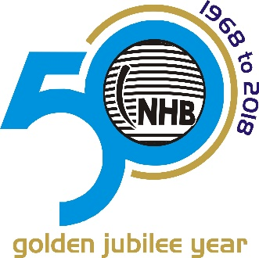

NHB Celebrated 50 years of Steel ball establishment on auspicious day of Dussehra, 18th October 2018. It all started in the year 1968 on Dussehra day in INDIA, State of Gujarat in Amalsad village, which has a nice and warmth ambiance, such as ponds, different colored lotuses and greenery, in short it is like heaven.

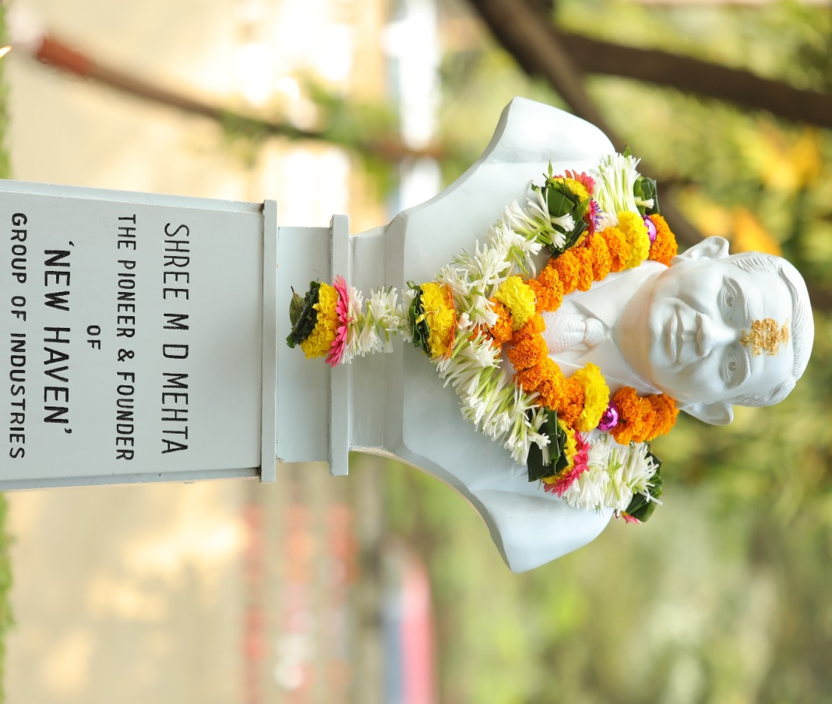

Day started by garlanding to Shree M. D. Mehta’s statue
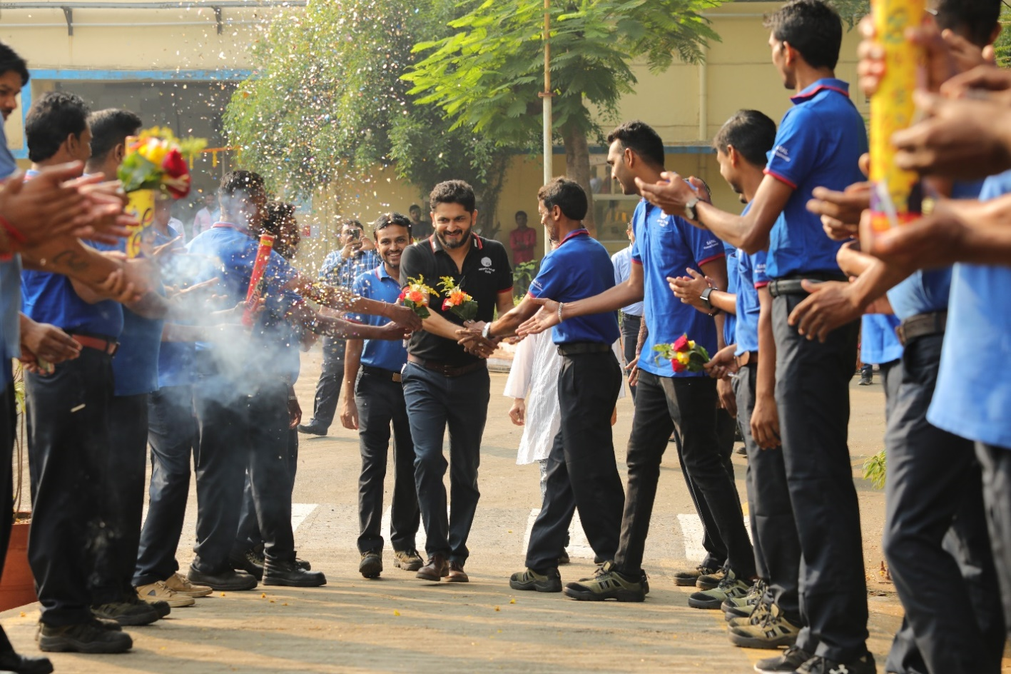
(Group photo: NHB SARAL Team welcoming Mr. Kalpesh Mehta – Managing Director)
The picture shows the bonding between the operators and top management, which makes everyone to associate with NHB.

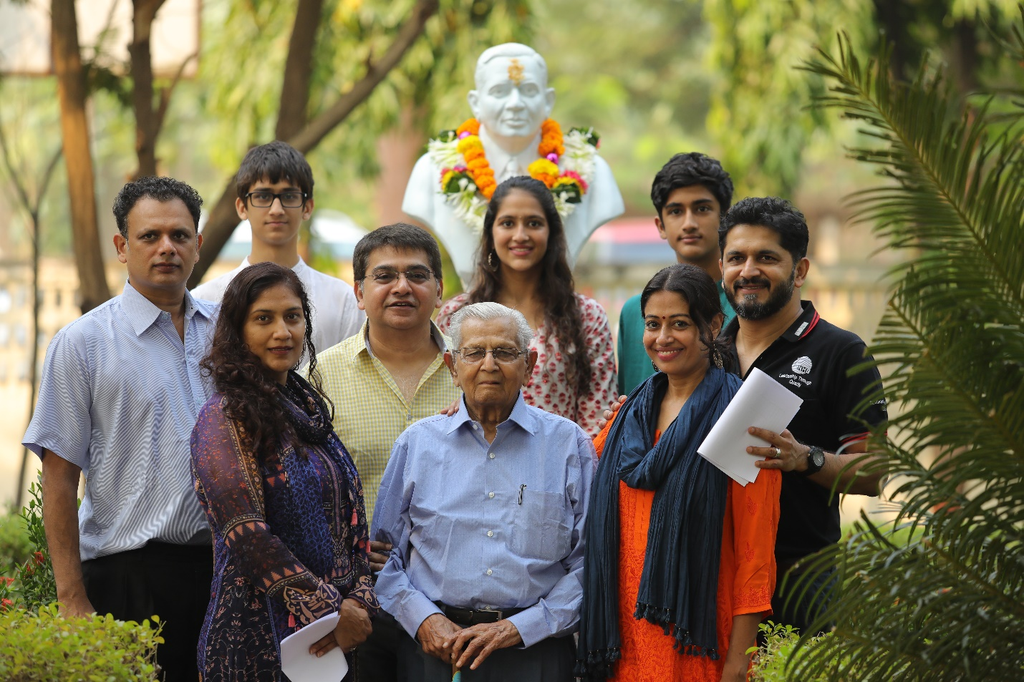
NHB Group - Directors & Family
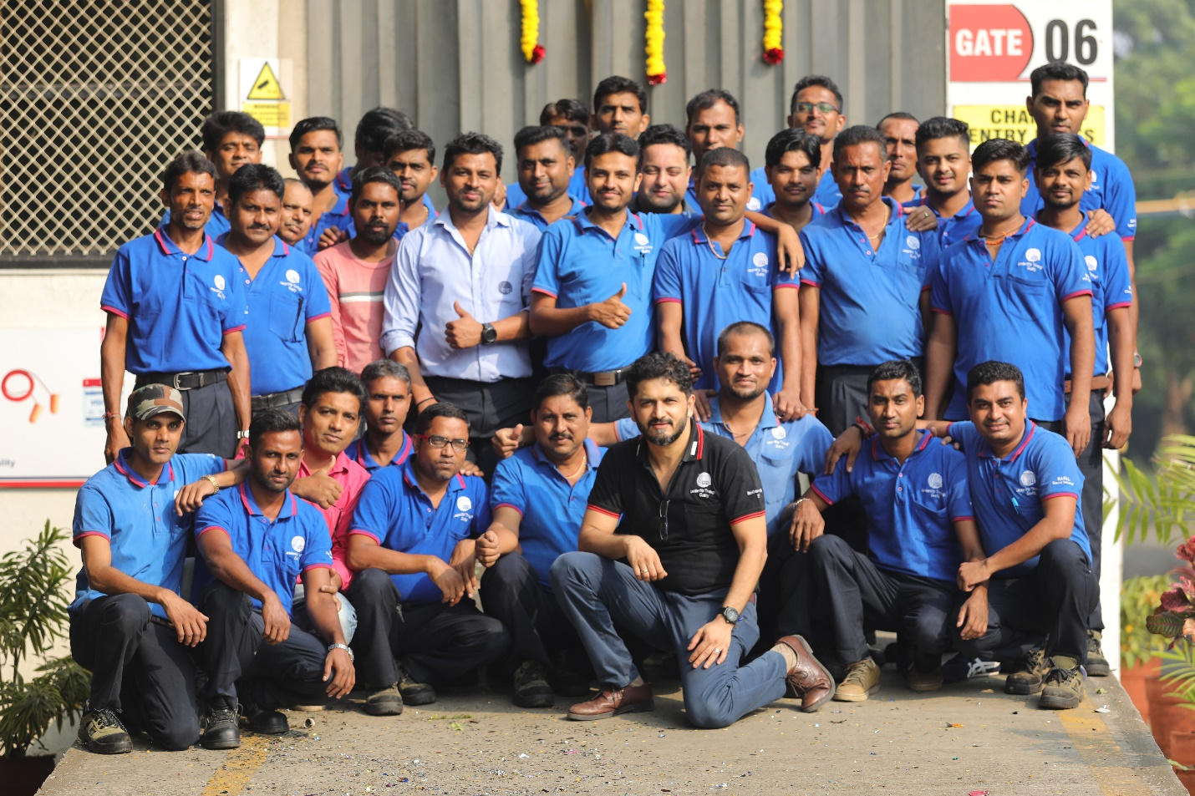
NHB SARAL Team: Comprising of Managing Director, Channel Manager, Advance Team Leaders & Operators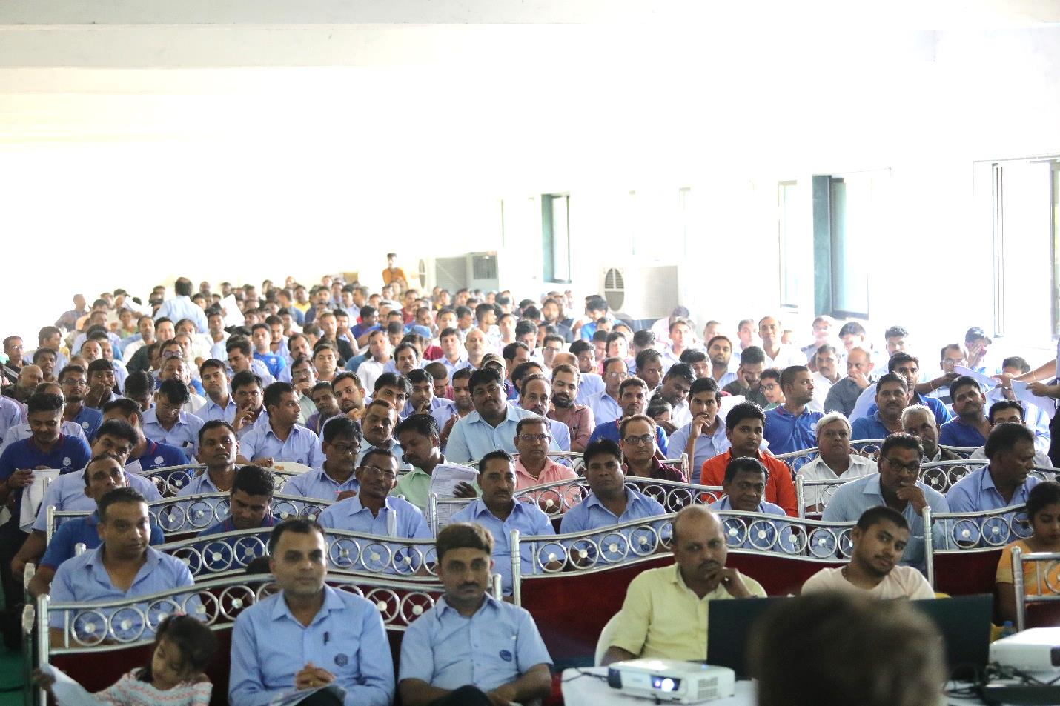
NHB Parivar: Comprising of staffs, Union leaders, operators and their family & Business partners.
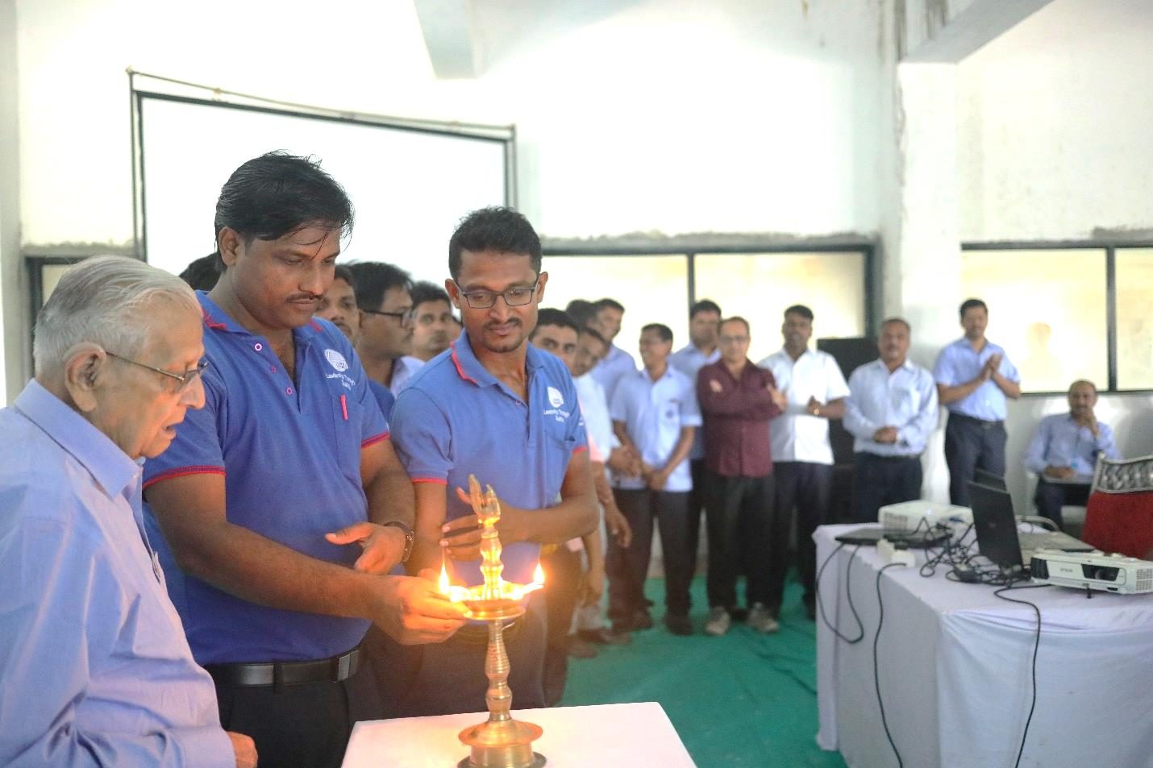
Chairman, Team leaders lighting the Diya
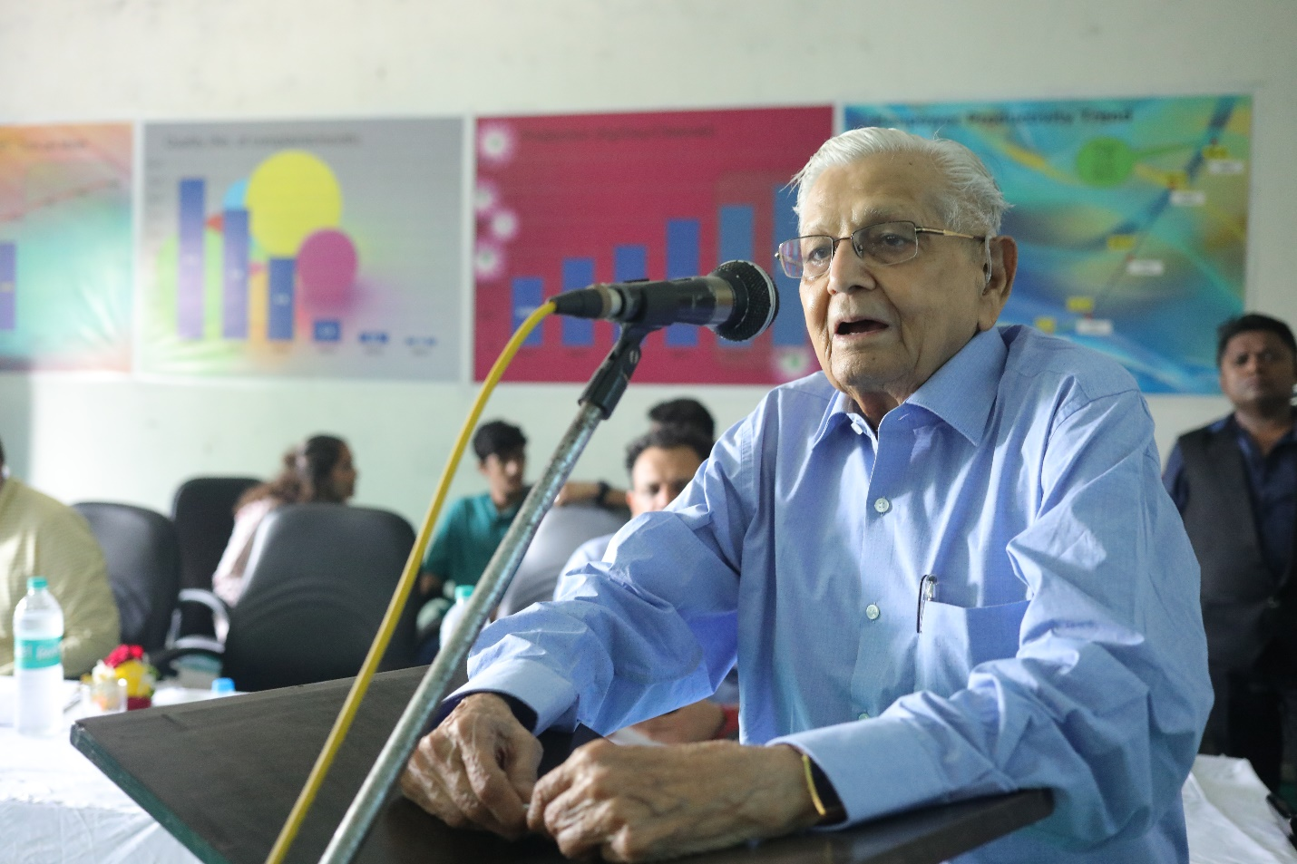
Addressing NHB Parivar by Chairman Shree H. M. Mehta
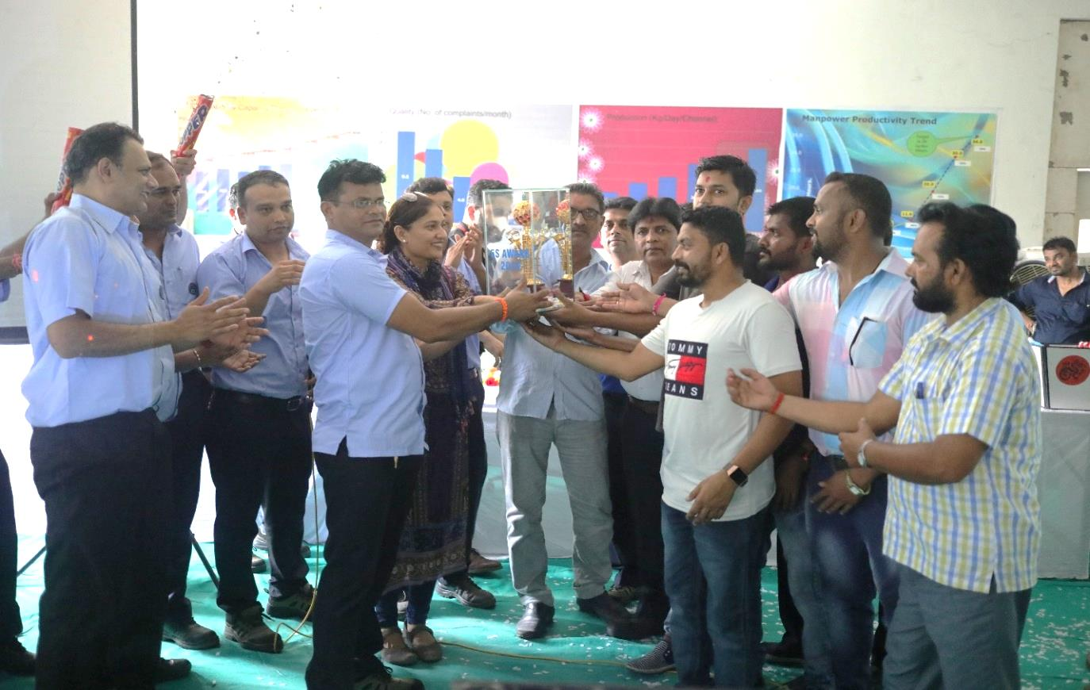
5S Award of the year (2017-18) Winner: Flashing team for Amalsad plant.
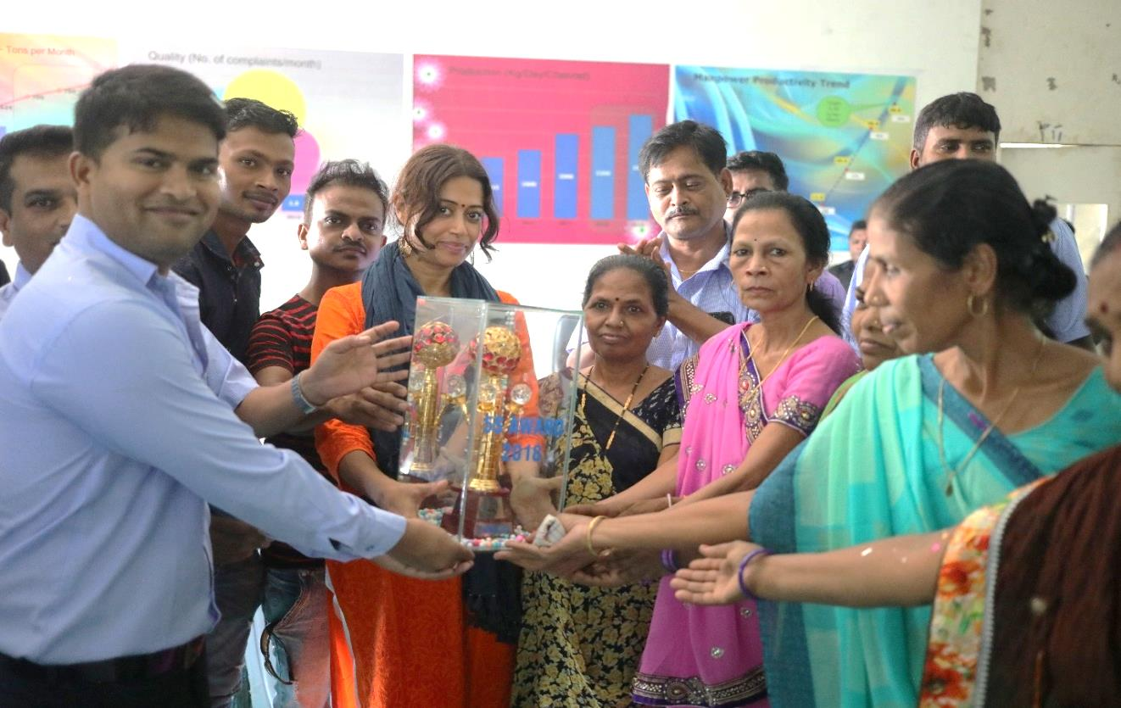
5S Award of the year (2017-18) Winner: Quality team for Bilimora plant.
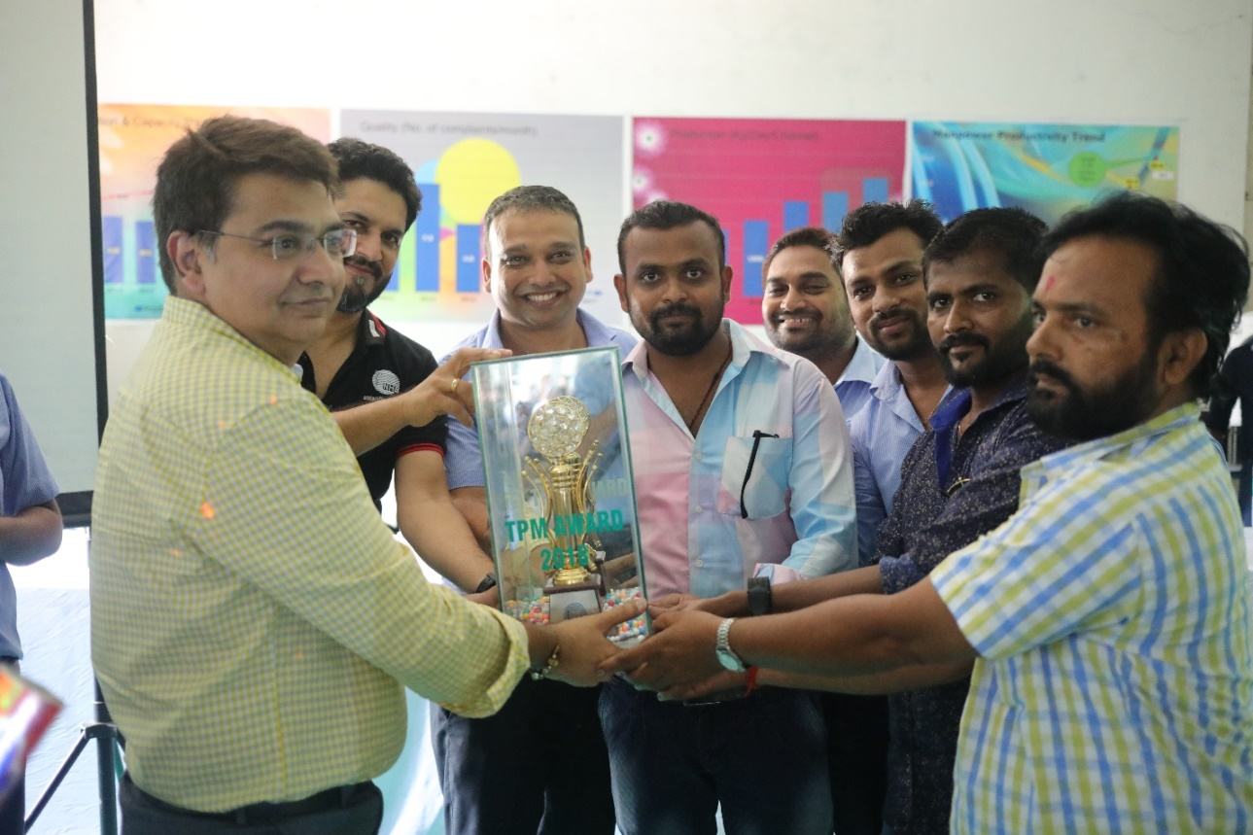
TPM Best Circle Award of the year (2017-18) Winner: Flashing Circle for Amalsad plant.
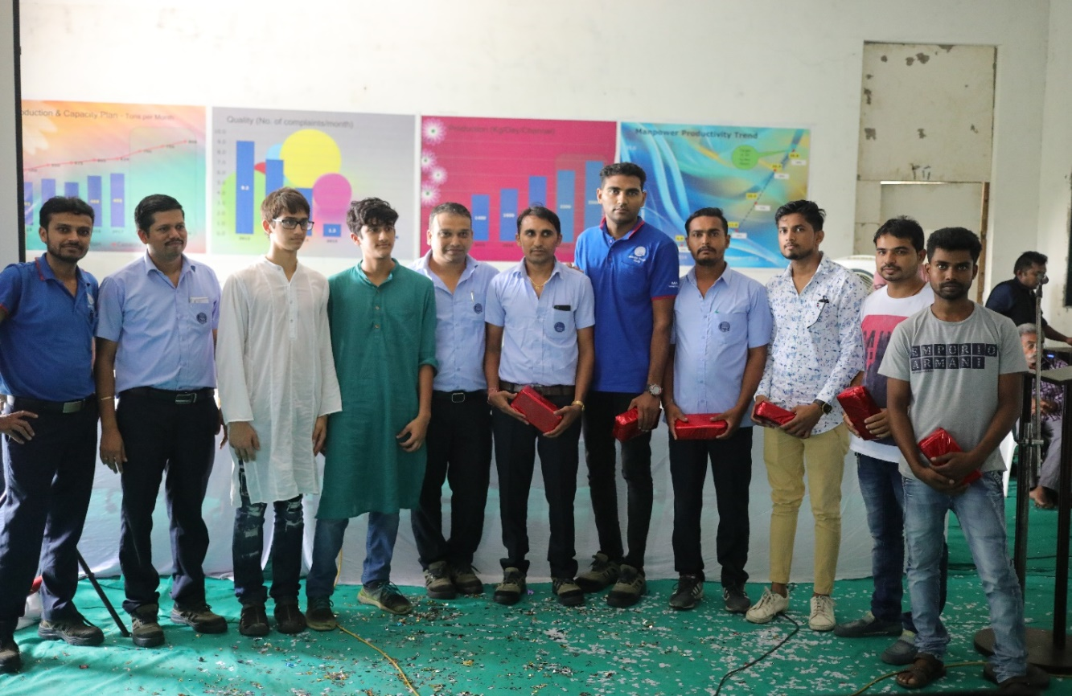
TPM Quiz competition (2017-18) Winners – Amalsad & Bilimora Plants
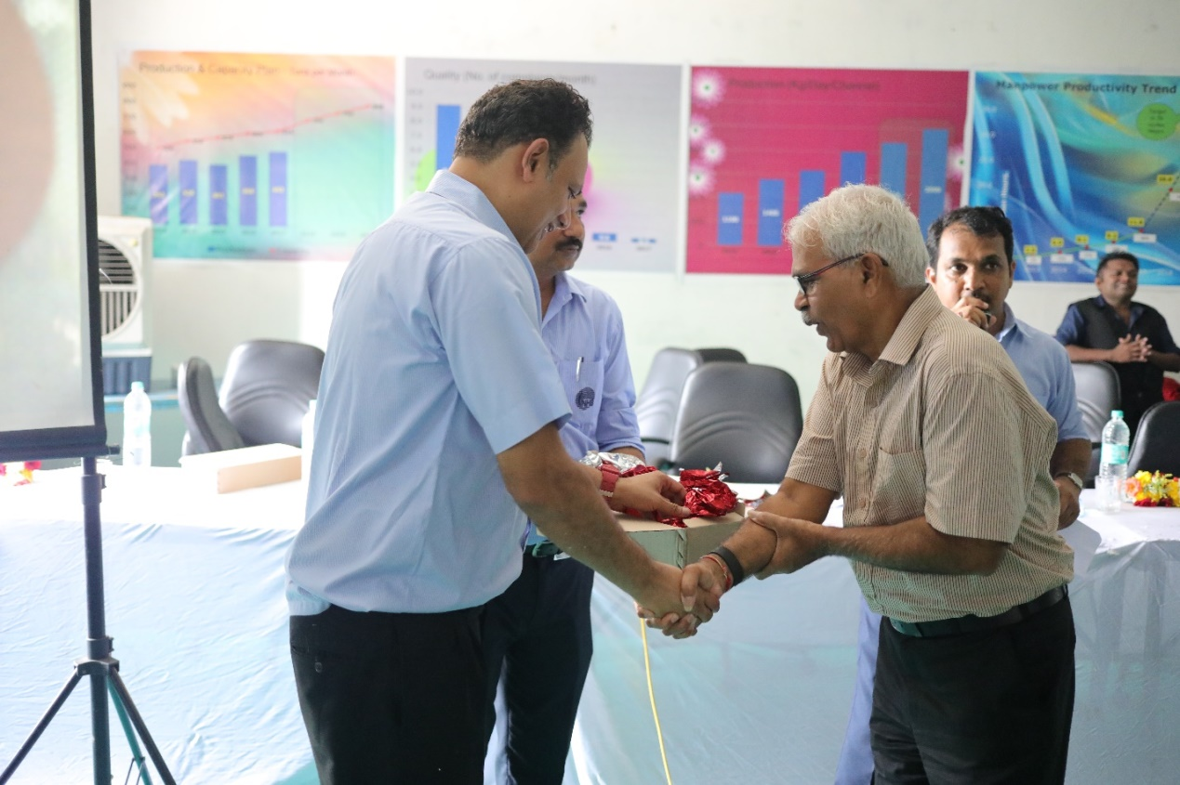
Momento to Business partners
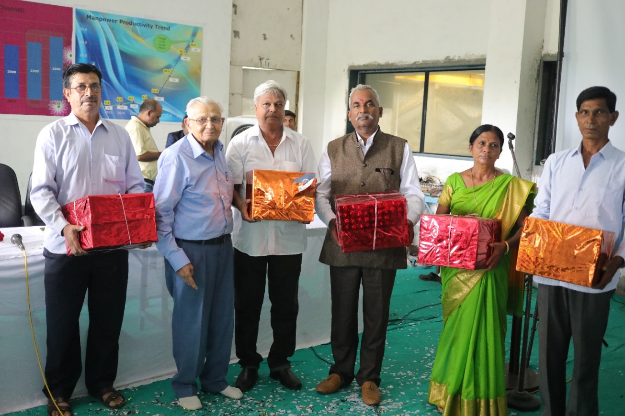
Gift to Retired employees (2017-18)
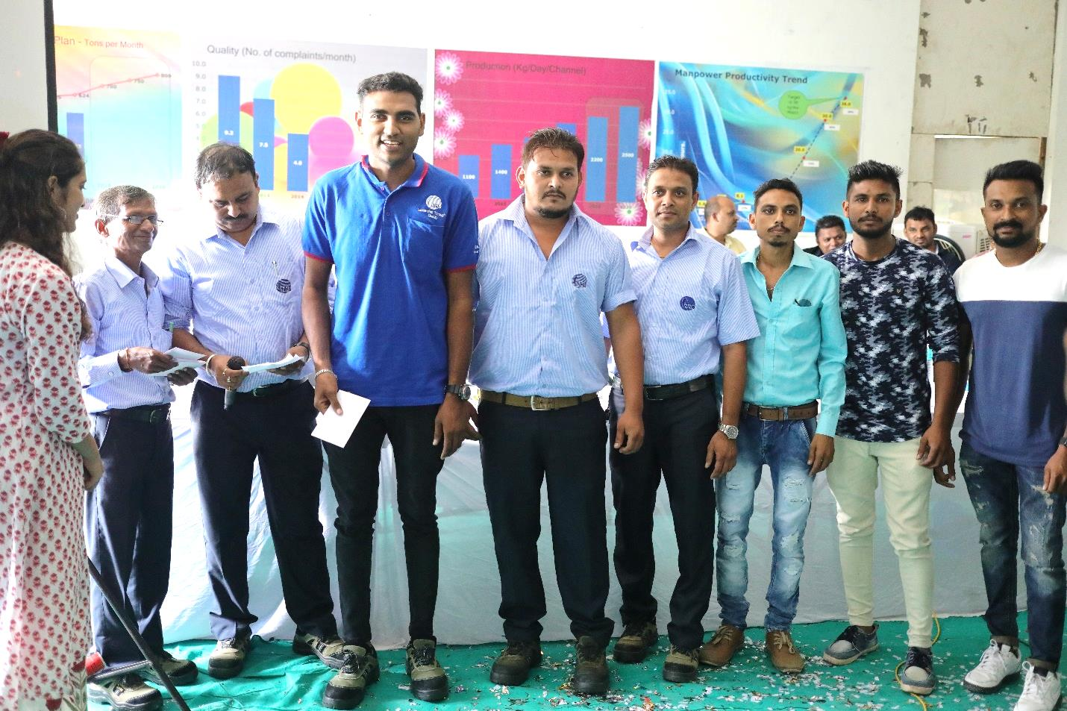
Sports day Winners for the year 2017-18
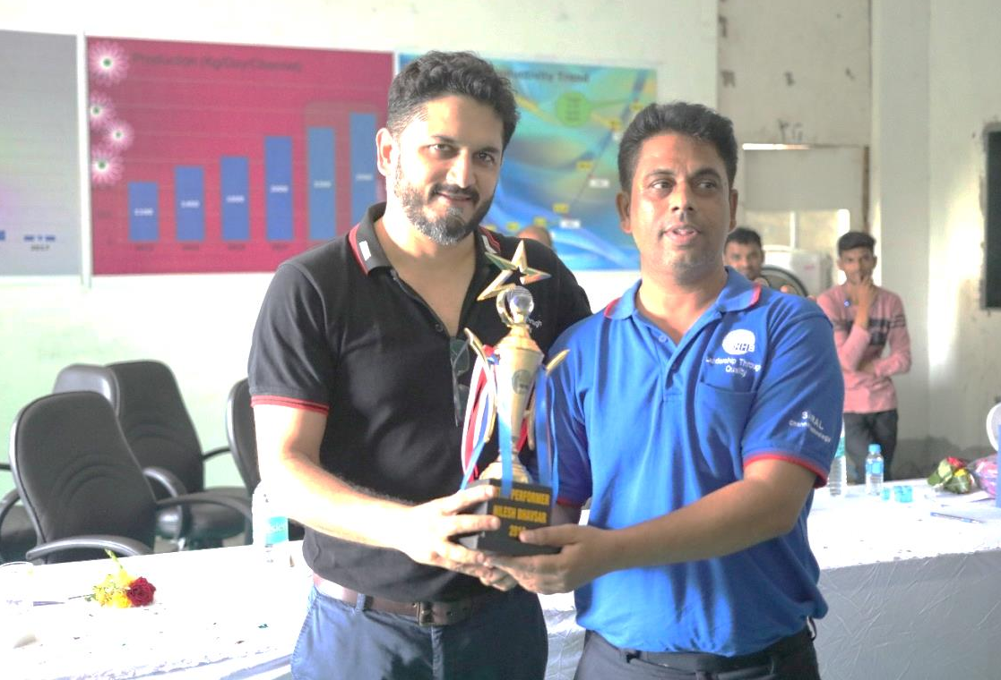
Star Performer of the Year Award to Mr. Nilesh Bhavsar (2017-18)

